Check in time: ___________ Checked in by: ________________ ❏ Drop off
❏ File Pulled ❏ File Scanned ❏ NEO only

Exam / Treatment Form

Check One: ❏ New client ❏ Existing client ❏ New patient

Last Name on File:
Pet’s Name:
Date:

Breed:
Sex: ❏ M ❏ MN ❏F ❏FS Age: ___________
Pet Insurance? ❏Yes ❏ No Insurance Provider? ____________________ Policy number? _____________________
For accurate vaccine/appointment reminders, please provide a cell/mobile number & email for our system.
Cell/Mobile: _____________________ Email Address: __________________________________________
What will we be seeing your pet for today?

Primary Complaints: ❏ None
❏Vomiting ❏Blood in urine ❏Itching ❏Painful ❏Diarrhea ❏Coughing ❏Hair loss
❏Growth/Lump ❏Blood in stool ❏Sneezing ❏Lethargic ❏Ears ❏Inappropriate Urination
❏Difficulty Breathing ❏Anorexia ❏Eyes ❏Difficulty Urinating ❏Lameness/Limping
❏Increased thirst ❏Other:

If your pet has any unusual lumps, bumps, wounds, or skin irritation which you would like the

Doctor to address today. Please note the location of each on the diagram. Left (Back) Right Right (Belly) Left

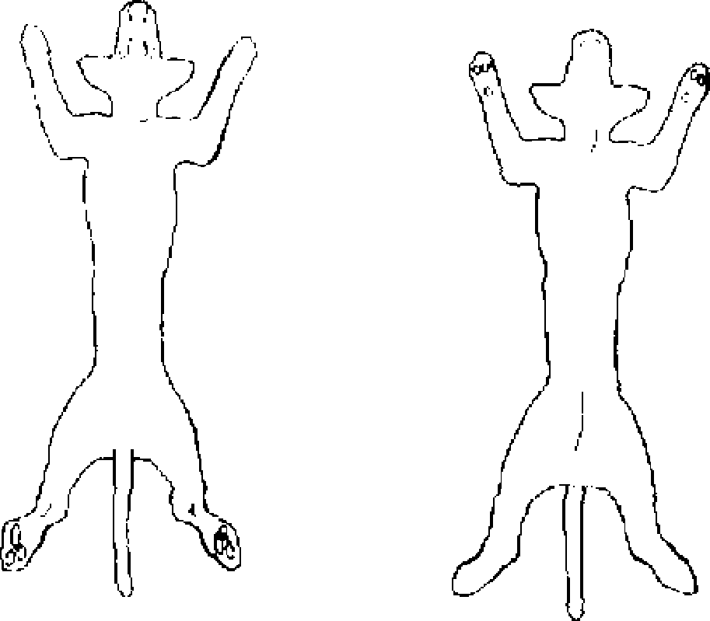
______________________________________________________________________

______________________________________________________________________

Has your pet had an increase or decrease in any of the following:

Appetite: ❏increased ❏decreased ❏No Change
Drinking: ❏increased ❏decreased ❏No Change
Urination: ❏increased ❏decreased ❏No Change
Defecation: ❏increased ❏decreased ❏No Change
Weight: ❏increased ❏decreased ❏No Change

Was your pet fed today? ❏No ❏Yes Time of meal: ________________
Is your pet current on vaccinations? ❏No ❏Yes Date given?
What is your pet’s diet? ________________________________________
Any previous illness/surgery? Is your pet on any medications/flea control? ❏No ❏Yes, please list:
Has your pet been seen by another veterinarian? ❏No ❏ Yes Name of clinic? ________________________________
May we call for records? ❏Yes ❏No
Best number to contact you today (please print clearly) :__________________________________

